Lab Title: General introduction to Wireshark and networking

Objective of this lab:

The basic purpose of this lab is to introduce you to Wireshark, a popular protocol analyzer. By the end of this lab you will be familiar to its environment and will know how to capture and interactively browse the traffic running on a computer network using it.

Instructions:

- These exercises are to be done individually.
- You are supposed to provide the answers to the questions and upload this completed document to your course’s LMS site.
- Avoid plagiarism by copying from the Internet or from your peers. You may refer to source/ text but you must paraphrase the original work.
Questions:

- Finding IP address of your machine in Wireshark: What is the IP address of ‘seecs.nust.edu.pk’? What is the IP address of your computer? How did you find it in Wireshark? Compare the IP address of your machine by using ipconfig command.

IP address of my computer: 10.99.16.28
IP address ‘seecs.nust.edu.pk’: 10.3.20.64
I used the http filter in Wireshark to filter out the packets send and received using http. The first http message shown in the packet-listing window was the request I send to ‘seece.nust.edu.pk’ and the second was the OK response I got from the SEECS server.
I then compared the IP address of ‘seecs.nust.edu.pk’ received from Wireshark with the one I got by pinging in CMD. It was the same.
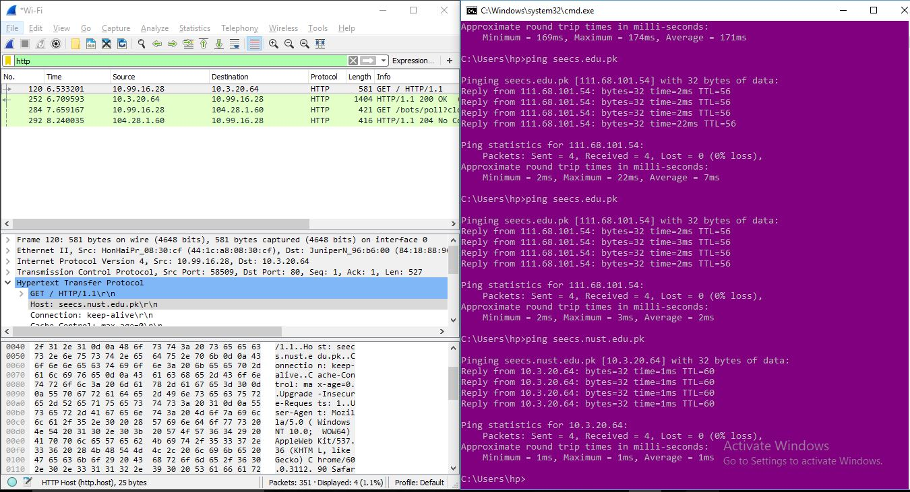
- What is the port number used by the HTTP server ‘seecs.nust.edu.pk’. How did you note it in Wireshark?

Port number: 80. It was mentioned in the TCP segment as the destination port (Dst Port).

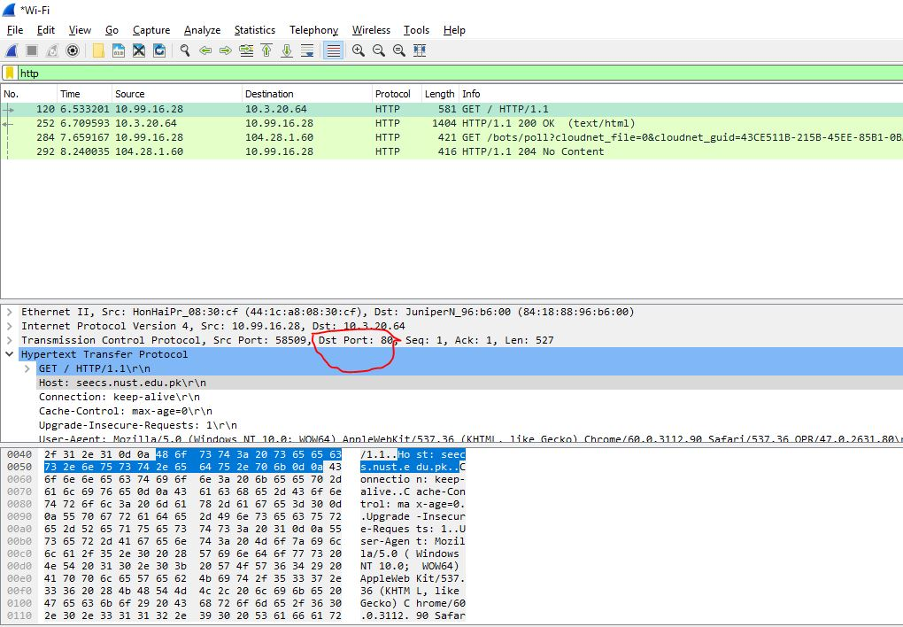

- Delay between request and reply: How long did it take from when the HTTP GET message was sent until the HTTP OK reply was received? (By default, the value of the Time column in the packet-listing window is the amount of time, in seconds, since Wireshark tracing began. To display the Time field in time-of-day format, select the Wireshark View pull down menu, then select Time Display Format, then select Time-of-day.)

Time delay: 0.176392 sec

For this part, you need to run your UDP client code that you wrote in Lab2 and connect with the UDP server being run by your neighbor. Capture the traffic for the interaction and answer the following.

- Identify the Four tuples: Find out the IP address of the client, port No of the client, IP address of server and port No of server by looking at the request packet sent by client and response message sent by the server? Where did you find these 4 values in the packet headers?

IP address of the client: 10.99.16.28
Port no of the client: 63860
IP address of the server: 10.3.31.203
Port no of the client: 15000

The IP address of the client and server were in the ‘Internet Protocol Version 4’ header.
The port number of the client and server were in the ‘User Datagram Protocol’ header.
- Header fields: What is the total frame size for request from client and the response from the server? How many bytes is the UDP and IP header?

Frame size for request from client: 47 bytes

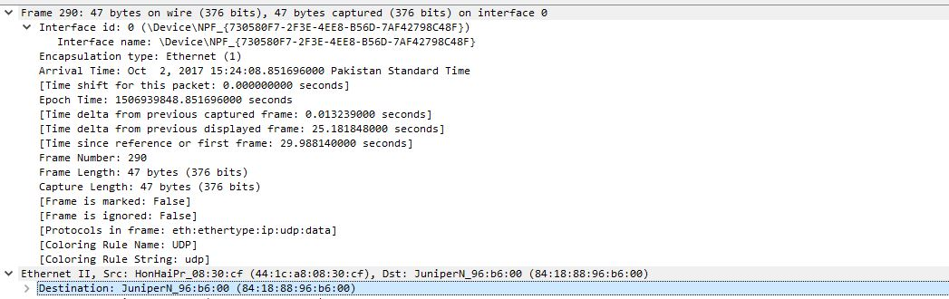

Frame size for response from the server: 60 bytes

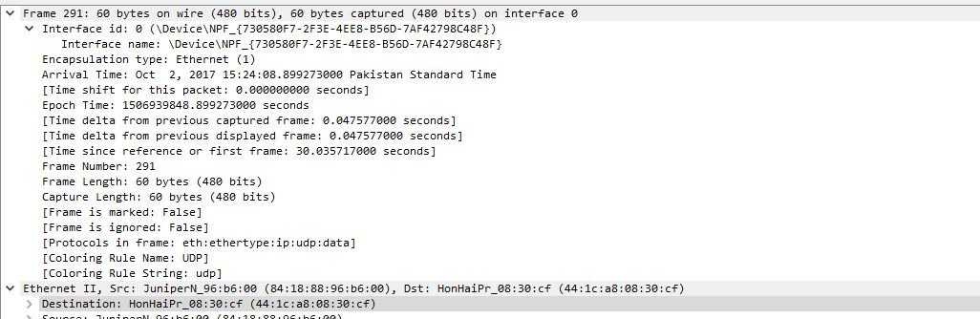
UDP length: 13
IP header length: 33

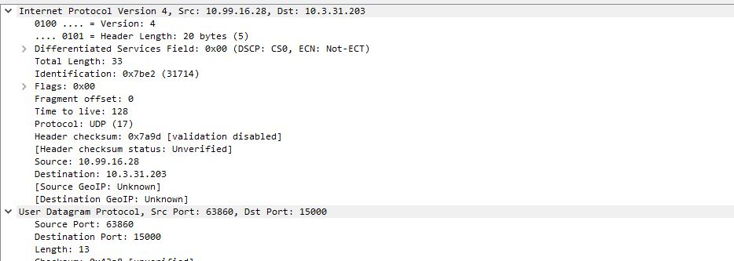

Part B:

1. Run your UDP and TCP python code (from lab 2) and capture the interaction between your client and server. Filter the trace such that only relevant frames are shown in the capture window. What is the major difference between the UDP and TCP trace?

IP address of the client: 10.99.16.28
Port no of the client: 59236
IP address of the server: 10.3.31.203
Port no of the client: 7800

Frame size for request from client: 54 bytes
Frame size for response from the server: 60 bytes

UDP length: 13
IP header length: 40

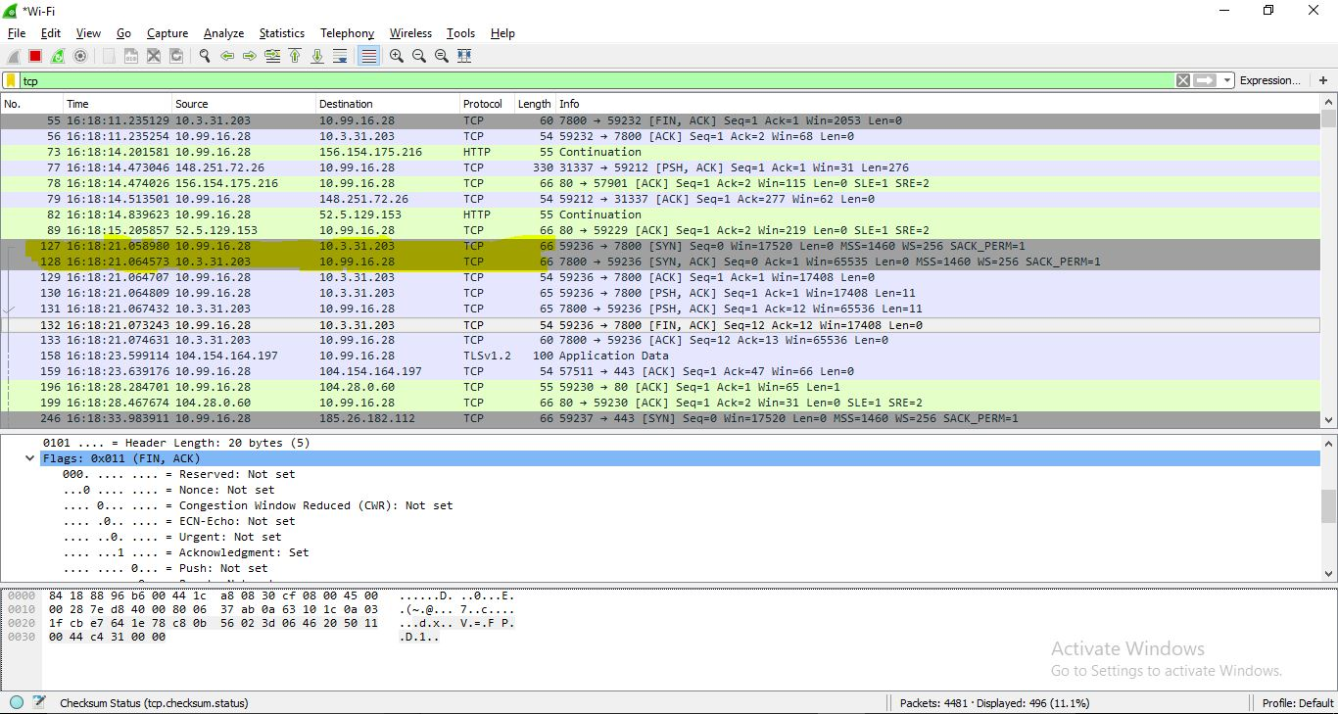

Major difference between UDP and TCP trace:
TCP first establishes a connection by exchanging packets. After the connection is established, it will allow the user to send or receive information over the internet.
On the other hand, UDP doesn’t care if the connection is established or not. It just transfers the packets whether it reaches the destination or not.

